# **Assignment 2 - Design**

|  |  |
| --- | --- |
| **TEAM MEMBERS** | Thehara Goonewardena, Julia Adams, Thivanka Goonewardane |
| **ID NUMBERS** | 32312512, 32312636, 32312644 |
| **COLLEGE NAME** | Monash College |
| **LECTURER NAME** | Sir Haren Lalchand |
| **DATE** | 23/04/2021 |

### **Table of contents**

**Assignment 2 - Design** **1**

Table of contents 2

Project Information- 3

Storyboard- 11

Class Design- 15

### **Project Information-**

The purpose of this project is to design a web app which will help students of Monash College to plan their travelling activities within the country for the whole semester or year, as the governments have started to ease the restrictions imposed on travelling due to the covid-19 pandemic.

This web app will allow the students to-

1. Schedule a trip- The student is able to select his/her source airport, destination airport, time and date. Once the student has selected a source airport, all the routes starting from that airport will be shown on a map.
2. Cancel a scheduled trip- Students are allowed to cancel any of the trips that they have booked for the future.
3. View all scheduled trips- A feature that allows students to view all of their trips, both old trips and trips that are booked for the future can be viewed using this feature.
4. View detailed trip information- The student is able to view all the details of the trip such as source airport, destination, date and time clearly.

**Design Decisions-**

1. The layout of the app is created in a user friendly manner with colors and fonts that appeal to the user. We have decided to use colors that aren't too bright.
2. A eye catching logo should be created.
3. Background color - Blue.
4. Font color - Black.
5. Main headings of each webpage will be in H1.
6. Buttons have been added as well as images to make the user interface more interactive.

**Wireframes-**

**Home page:-**

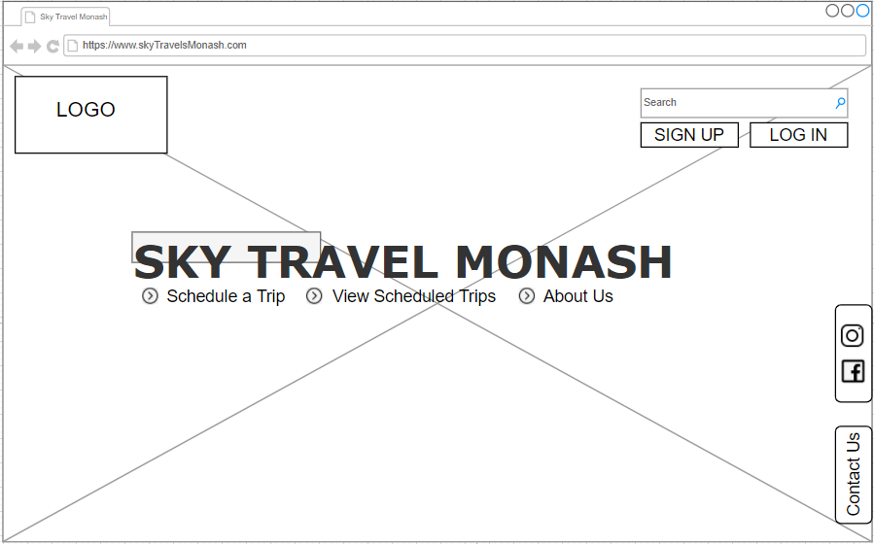

**Schedule a trip Page:-**

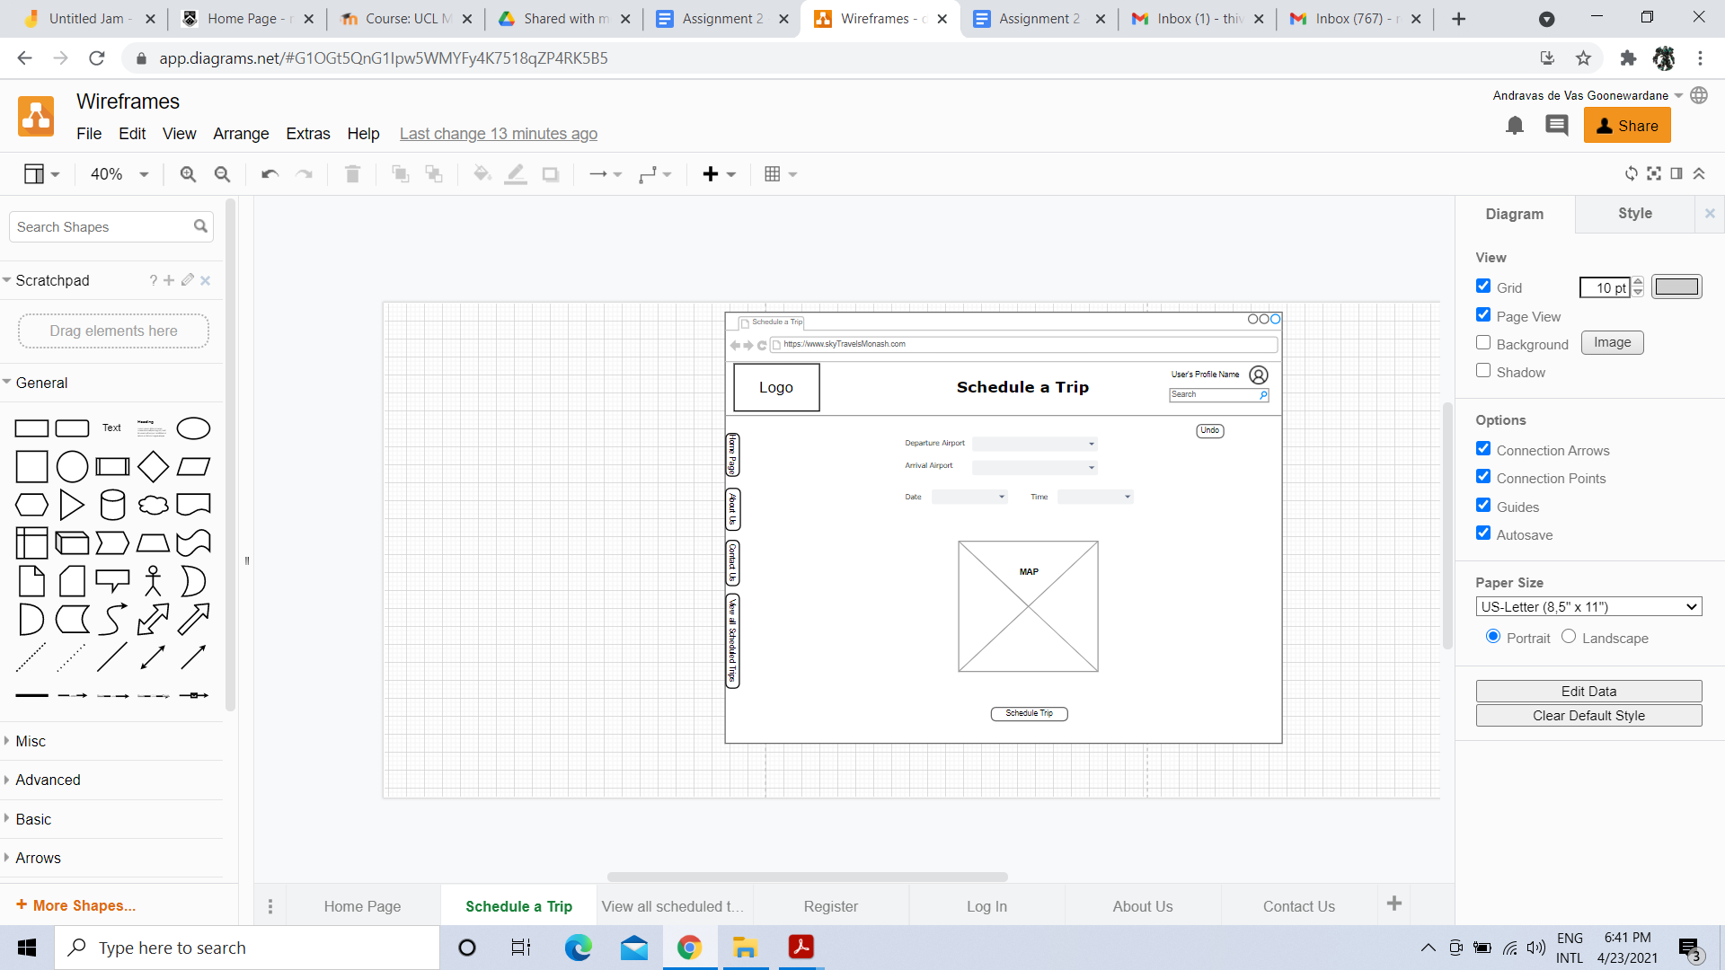

**View all Scheduled Trips Page:-**

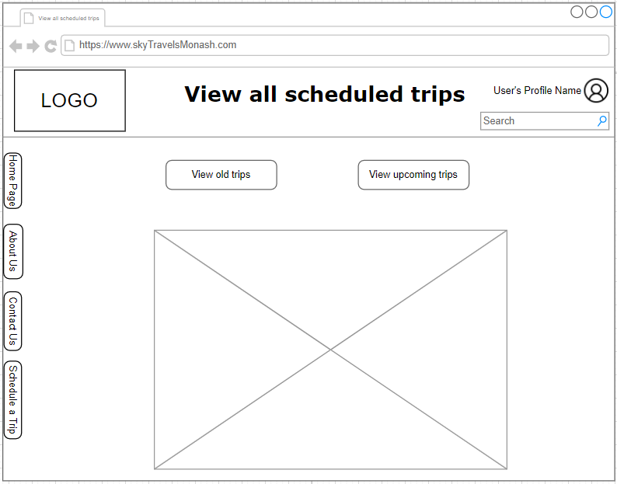

**Register Page:-**

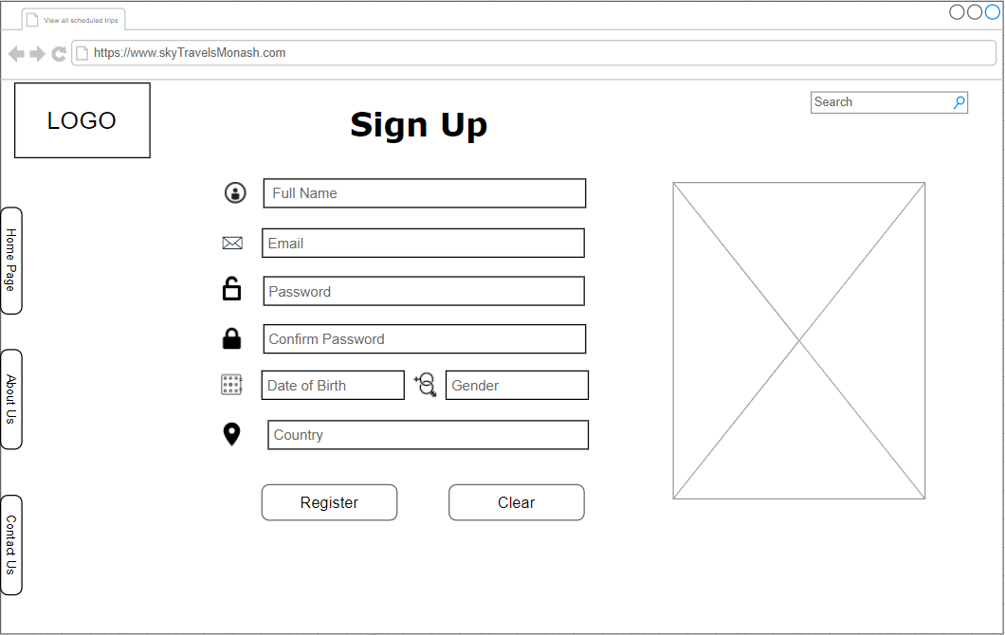

**Login page:-**

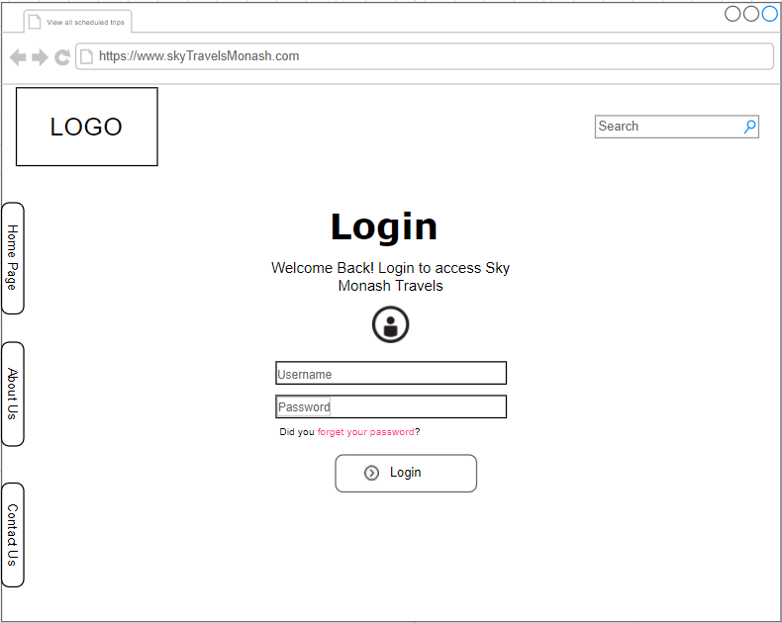

**About us page:-**

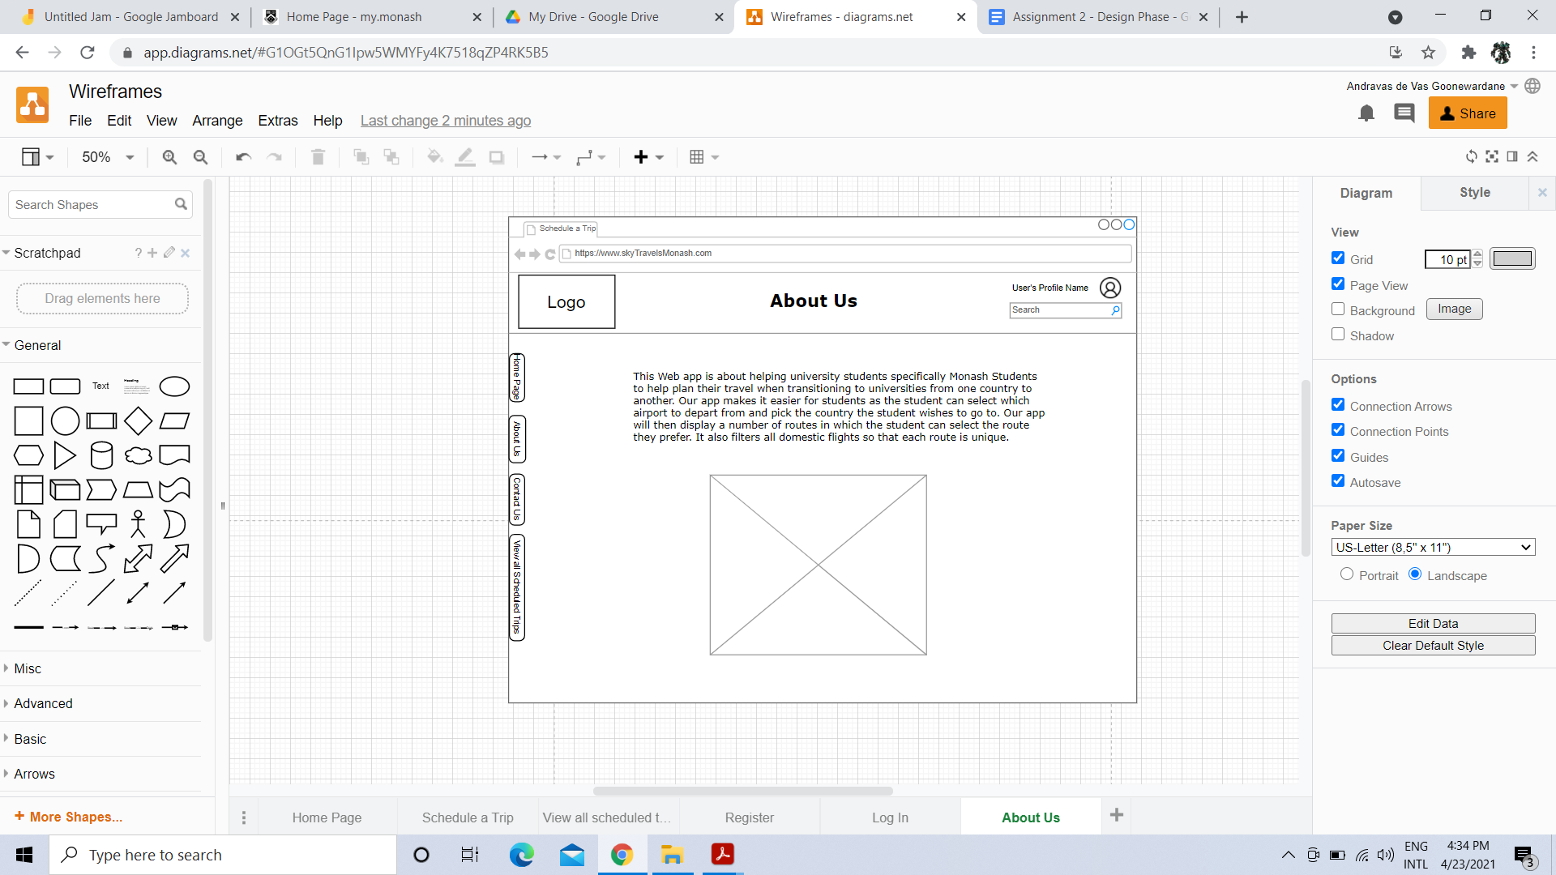

### 

### 

### 

### 

**Contact us page:-**

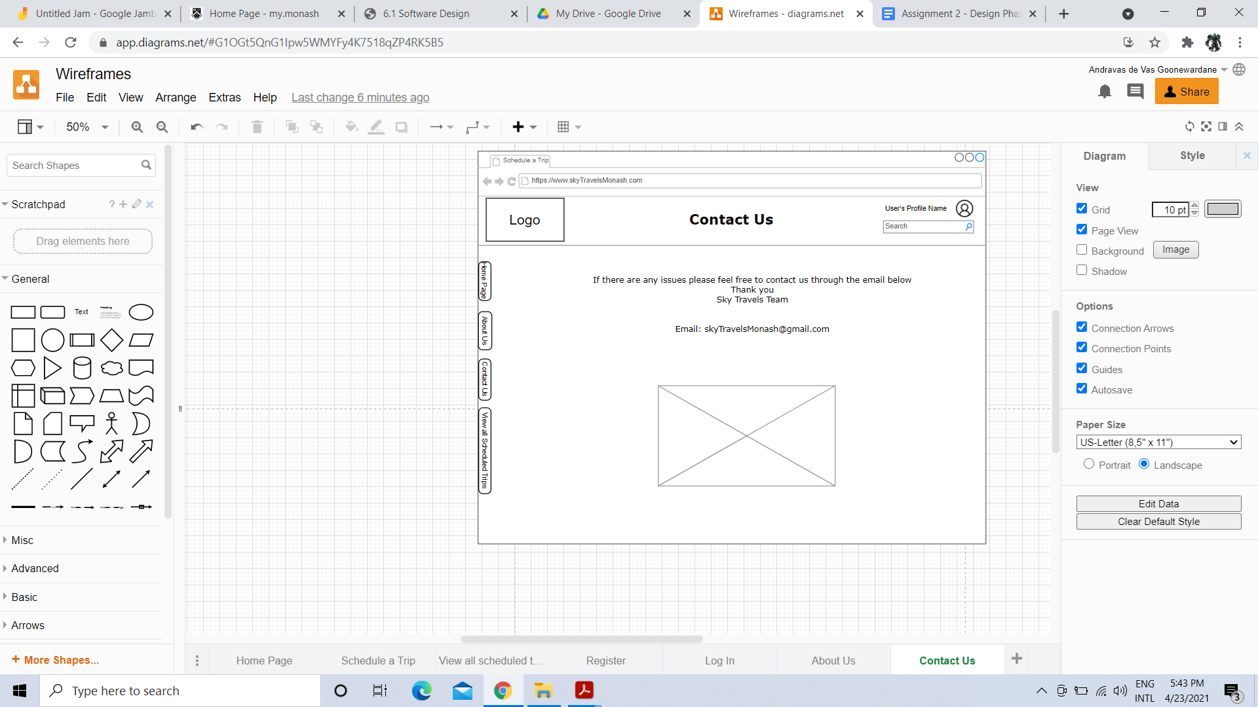

### **Storyboard-**

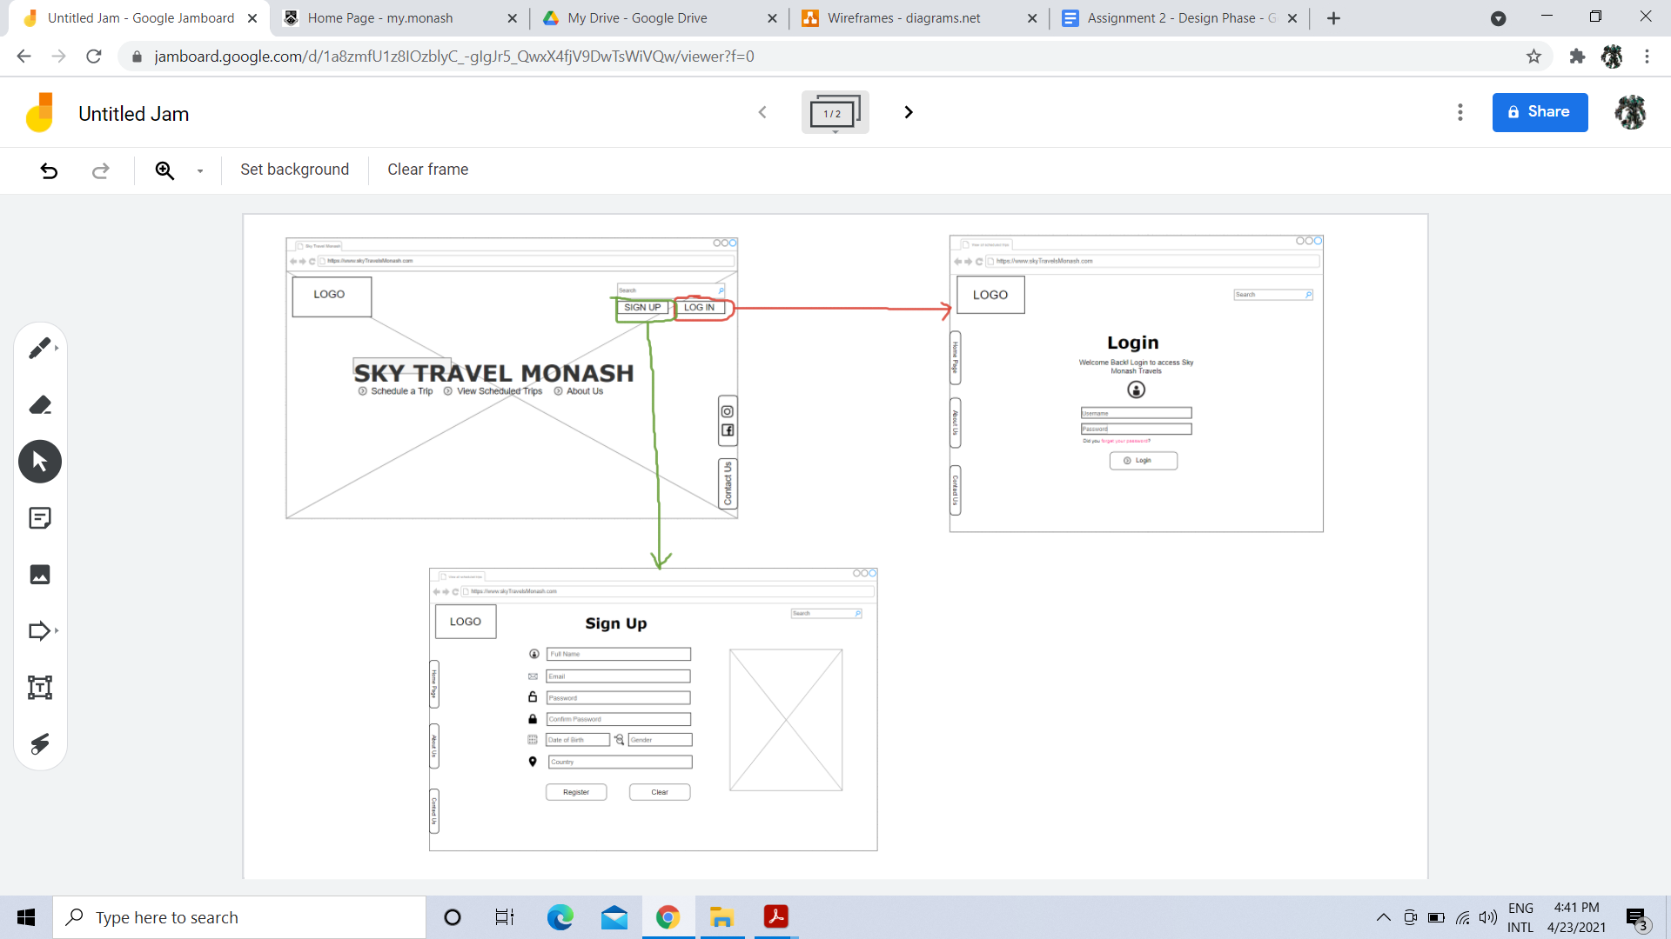

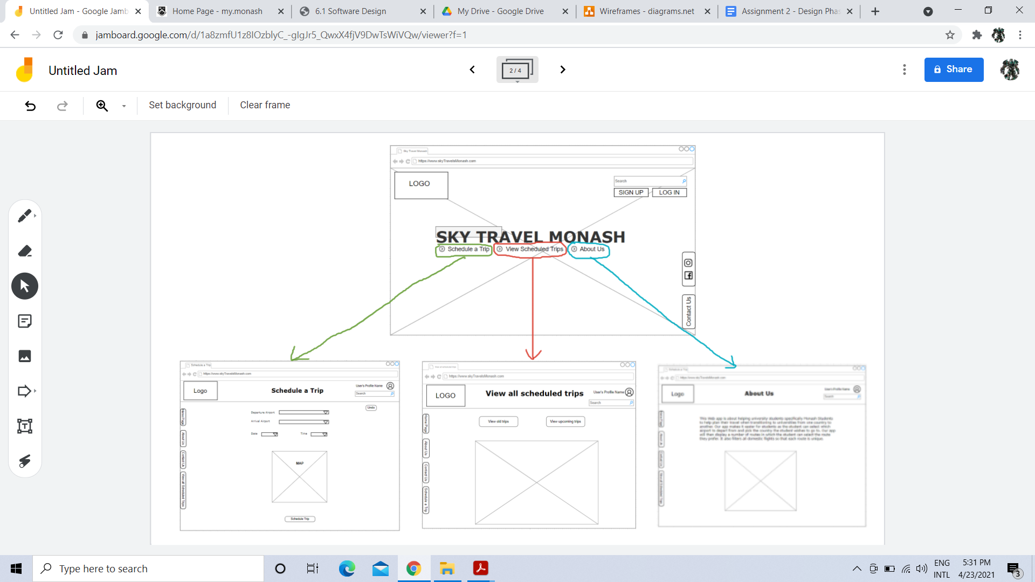

### 

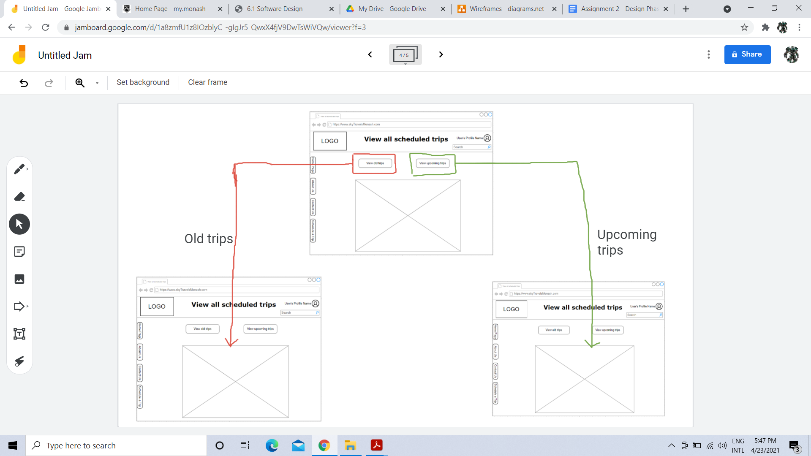

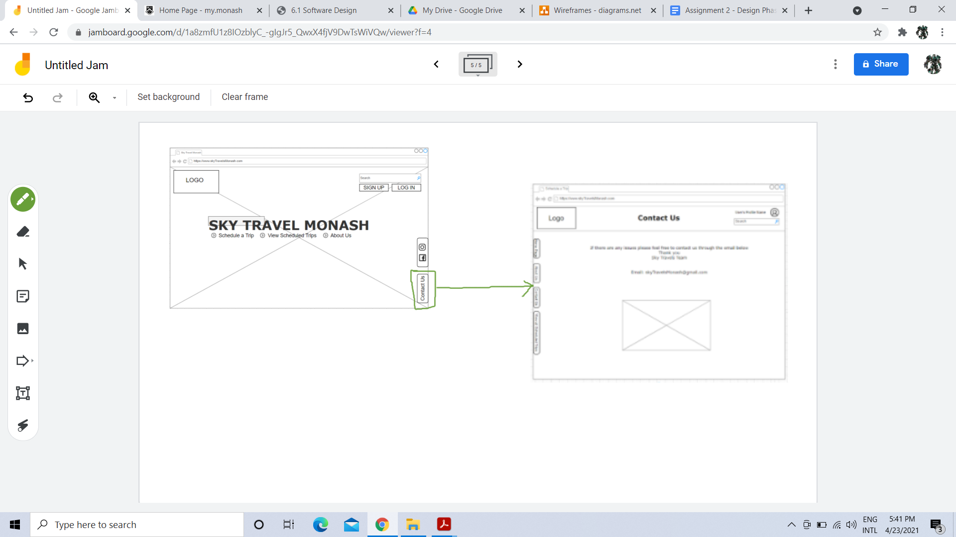

### **Class Design-**

